# **OS MANUAL**

Abdullah Khan |

A71004823004

|  |  |
| --- | --- |
| **Page NO.** | **TOPIC** |
| 1. | Linux Commands |
| **2.** | What Are Operators and Operands? |
| 3. | Arithmetic |
| 4. | Operators And Operands (Practical) |
|  |  |
|  |  |
|  |  |
|  |  |
|  |  |
|  |  |
|  |  |
|  |  |
|  |  |
|  |  |
|  |  |
|  |  |
|  |  |
|  |  |
|  |  |
|  |  |

# **Linux Commands:**

# ls- The most frequently used command in Linux to list directories

# pwd- Print working directory command in linux

# mkdir- Command used to create directory

# 

# cd- Linux command to navigate through directories

# touch- Create empty/blank files

# 

# echo- Print any text that follows any command

# 

# du- Measures the disk space occupied

# 

# grep- Used for searching texts in directory



# **What Are Operators and Operands?**

# In Linux, the terms "operator" and "operand" are primarily used in the context of shell commands and scripting. They refer to key components of command-line operations and expressions.

# Operator:

# An operator is a symbol or character used to perform specific operations or actions on one or more operands.

# Operators are used in Linux commands and scripting to manipulate data, perform comparisons, and control program flow.

# Common operators in Linux include arithmetic operators (+, -, *, /, %), logical operators (&& for AND, || for OR, ! for NOT), comparison operators (== for equal, != for not equal, < for less than, > for greater than, etc.), and assignment operators (= for assigning values).

# Operand:

# An operand is the data or value on which an operator acts or performs an operation.

# Operands can be variables, constants, or the result of previous operations.

# In Linux commands and scripting, operands are used to provide input data for operators to process.

# For example, in the arithmetic expression **5 + 3**, the numbers **5** and **3** are operands, and the **+** symbol is the operator. Similarly, in a conditional statement like **if [ $x -eq 10 ]**, **$x** is the operand, and **-eq** is the comparison operator.

# Here are a few examples of operators and operands in Linux:

# **Arithmetic Operation:**

# Operator: +

# Operands: 5 and 3

# Expression: **5 + 3**

# Logical Operation:

# Operator: &&

# Operands: Two commands or conditions

# Example: **command1 && command2**

# Comparison Operation:

# Operator: -eq (equal)

# Operands: **$x** (variable) and **10** (constant)

# Expression: **if [ $x -eq 10 ]**

# Assignment Operation:

# Operator: =

# Operands: Variable and a value

# Example: **x=5**

# String Concatenation:

# Operator: .

# Operands: Two strings

# Example: **result="Hello" . " World"**

# Operators and operands are fundamental components in Linux command-line operations and scripting, allowing you to perform a wide range of tasks, from basic arithmetic calculations to complex conditional statements and data manipulations. Understanding how to use them effectively is essential for working with Linux systems and writing shell scripts.

# Example:

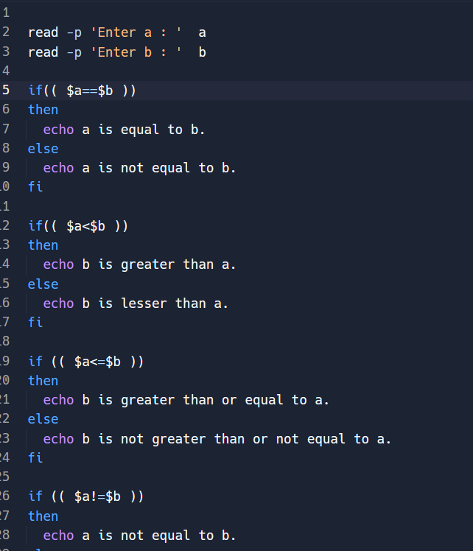

# Output -

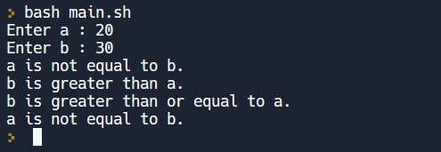

# Using different operands:

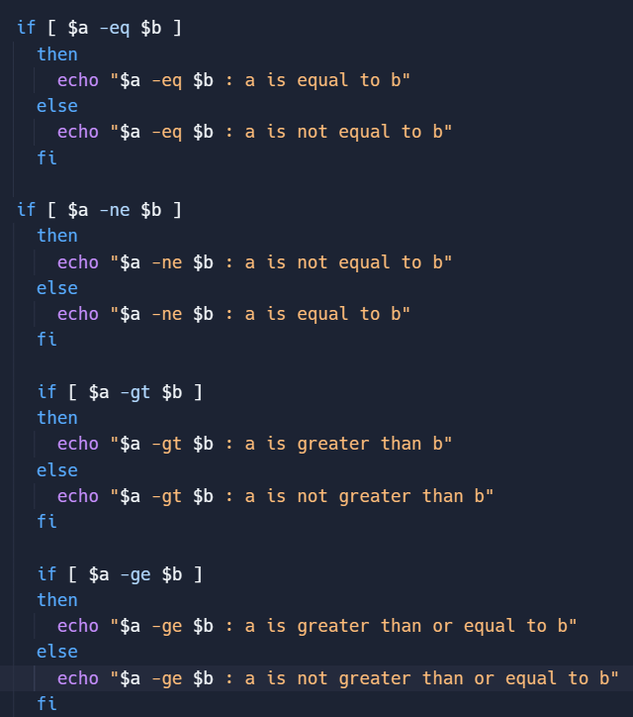

# Output-

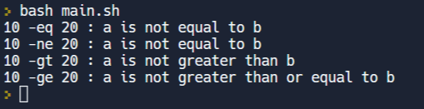

# Shell Program To Find GCD / LCM.

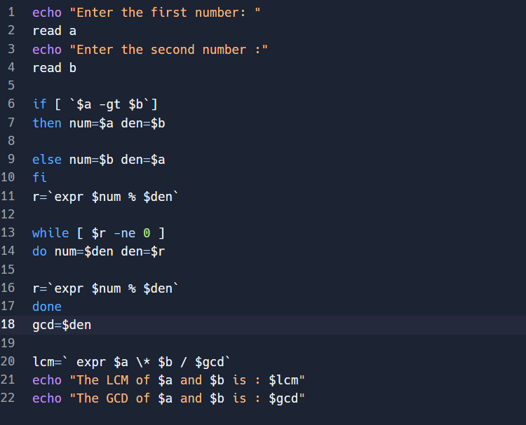

# Output –

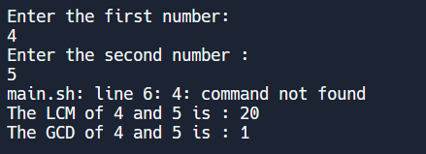

In arithmetic and number theory, the least common multiple, lowest common multiple, or smallest common multiple of two integers a and b, usually denoted by lcm, is the smallest positive integer that is divisible by both a and b.

The greatest common divisor of two or more integers, which are not all zero, is the largest positive integer that divides each of the integers. For two integers x, y, the greatest common divisor of x and y is denoted.